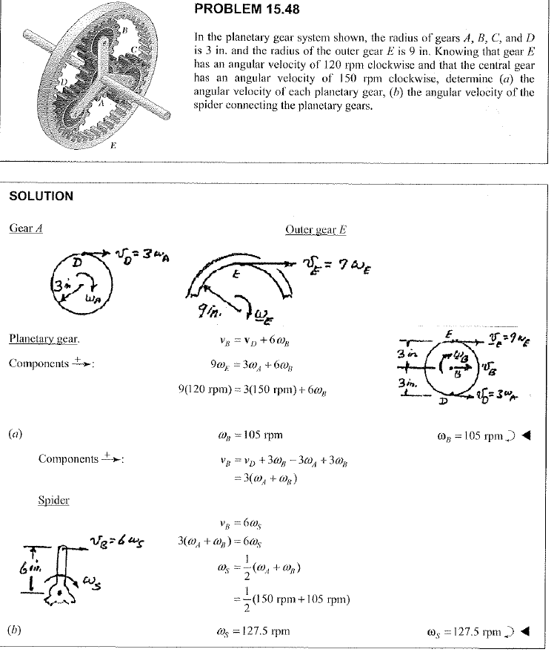

{ωp​−ωc​=ωc​−150,120−ωc​=31​(ωp​−ωc​).​

